**PSG COLLEGE OF TECHNOLOGY**

**DEPARTMENT OF COMPUTER APPLICATIONS**

**I MCA**

**23MX17 DATA STRUCTURES LABORATORY**

**List Problem sheet-II**

**Date: 05-09-2024                          Due date: 19-09-2024**

1. Given a list lst[ ] of size N, the task is to find the length of the Longest Increasing Subsequence (LIS) i.e., the longest possible subsequence in which the elements of the subsequence are sorted in increasing order.

Examples:

Input: lst[] = [3, 10, 2, 1, 20]

Output: 3

Explanation: The longest increasing subsequence is 3, 10, 20

Input: lst[] = [50, 3, 10, 7, 40, 80]

Output: 4

Explanation: The longest increasing subsequence is [3, 7, 40, 80]

Input: lst[] = [30, 20, 10]

Output:1

Explanation: The longest increasing subsequences are [30], [20] and (10)

Input: lst[] = [10, 20, 35, 80]

Output: 4

Explanation: The whole list is sorted

1. Given two sorted lists, lst1[] and lst2[], the task is to find the median of these sorted lists, where n is the number of elements in the first list, and m is the number of elements in the second list.

Examples:

Input: lst1[] = [-5, 3, 6, 12, 15], lst2[] = [-12, -10, -6, -3, 4, 10]

Output: The median is 3.

Explanation: The merged list is lst3[] = [-12, -10, -6, -5 , -3, 3, 4, 6, 10, 12, 15]. So the median of the merged list is 3.

Input: lst1[] = [2, 3, 5, 8], lst2[] = [10, 12, 14, 16, 18, 20]

Output: The median is 11.

Explanation : The merged list is lst3[] = [2, 3, 5, 8, 10, 12, 14, 16, 18, 20]. The total number of the elements are even, so there are two middle elements.

Take the average between the two: (10 + 12) / 2 = 11

Input: lst1[] = [], lst2[] = [2, 4, 5, 6]

Output: The median is 4.5

Explanation: The merged list is lst3[] = [2, 4, 5, 6]. The total number of elements are even, so there are two middle elements.

Take the average between the two: (4 + 5) / 2 = 4.5

1. Given a list lst[ ] of size N. The task is to find the sum of the contiguous sub list within a lst[] with the largest sum.

Example:

Input: lst = [-2,-3,4,-1,-2,1,5,-3]

Output: 7

Explanation:

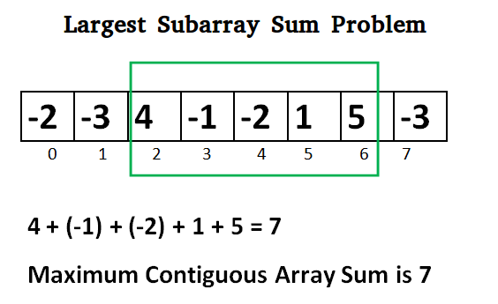

Input: lst = [2]

Output: 2

Explanation: The sublist [2] has the largest sum 2.

Input: lst = [5,4,1,7,8]

Output: 25

Explanation: The sublist [5,4,1,7,8] has the largest sum 25.

1. Given a list, cyclically rotate the list clockwise by one.

Example

Input: lst = [1, 2, 3, 4, 5]

Output: lst = [5, 1, 2, 3, 4]

1. Given a list lst[] of N distinct elements and a number K, where K is smaller than the size of the array. Find the K’th smallest element in the given list.

Examples:

Input: lst[] = [7, 10, 4, 3, 20, 15], K = 3

Output: 7

Input: lst[] = [7, 10, 4, 3, 20, 15], K = 4

Output: 10